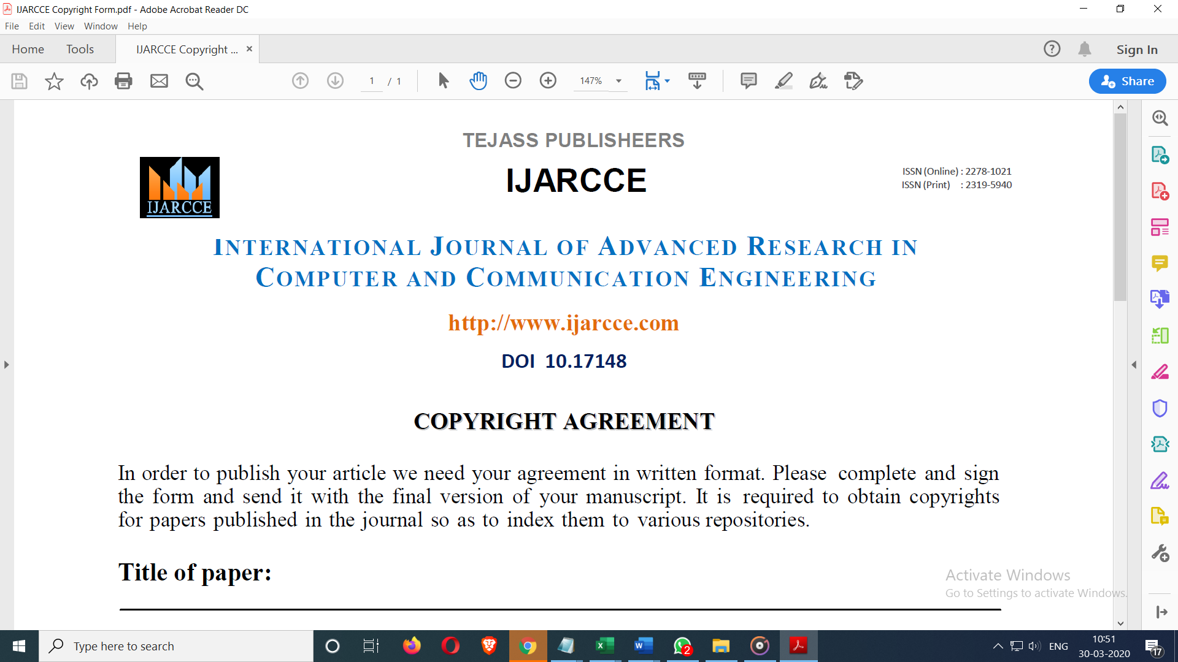

# Title of paper : Drive fatigue Monitoring and Accident Avoidance System using ML

**Author’s Name :**

**Dr. Manju Bargavi,**

**Pankaj Kumar Yadav**

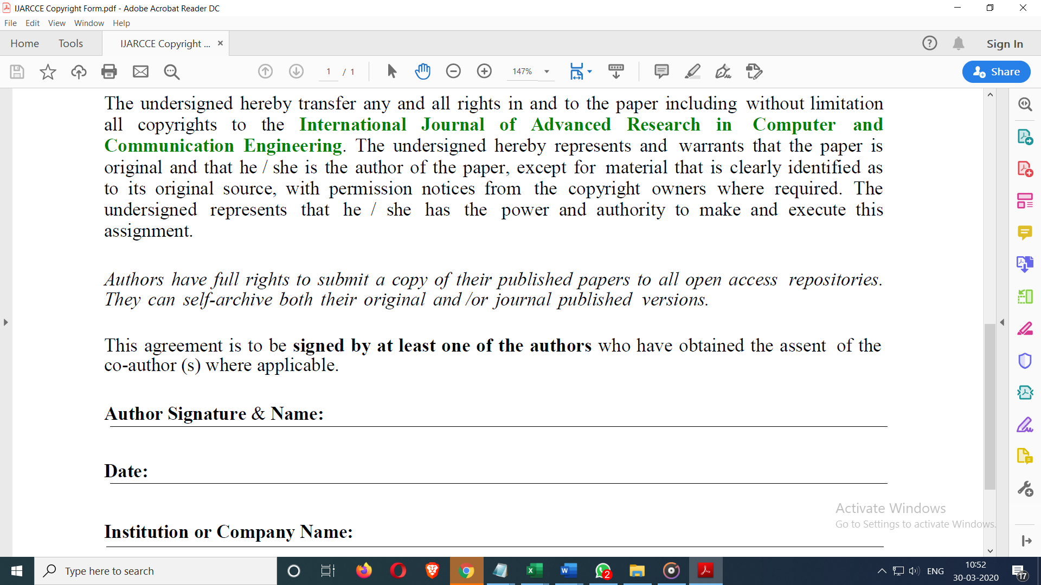

**Author Name: Pankaj Kumar Yadav**

**College/University Name: Jain University**

**Date: 05-04-2023**

